

American International University-Bangladesh (AIUB)  
**Department of Computer Science  
Faculty of Science &Technology (FST)**

***“Air Ticket Reservation System”.***

A software Requirement Engineering Sec: ***B***

project submitted By

|  |  |
| --- | --- |
| **Student name** | **Student ID** |
| ASHRAFUR RAHAMAN | 17-35211-2 |
| ROKON REZWANUR RAIS | 18-37122-1 |
| RAHMAN MAHFUZUR | 16-32638-3 |
| ISRAT HOSSAIN IZA | 17-33435-1 |

1. **PROBLEM DOMAIN**
   1. **Background to the Problem**

The objective & the purpose of this project is to design an “Air Ticket Reservation System” which will enable the passengers to search and book flights for normal time journey and also in case for emergency time journey such as Air paramedical support, business deals etc. This project will increase the profit and also reduce the extra cost and unnecessary exertion of the passengers and the flight companies. This report contains all the details of all the tasks carried out during the entire software requirement elicitation process for the Air Ticket Reservation System Project. This document depicts all the details of the project.

**Root cause & Importance:** Most of the air paramedic has to suffer lots of the hustle due to delay or cancellations of the flight, and also because of the checking of the documents manually which is a health risk. Due to delayed or the cancellation of the flight, most of the tradesman or merchant has to suffer lots of loses.

* 1. **Solution to the Problem**

**S**ystem will ask user about status of the journey. If the user has an emergency then the user can also booked two or more other aircrafts for the journey in case of flight cancellation or delayed if not then the user will get back the refund in case of flight cancellation or will be rewarded in case of delayed. On the other hand, in case of emergency user have to pay some extra cost for the back-up flight.

The main purpose of this vision document is to list the activity and the planning for the Air Ticket Reservation System project. This document helps us to collect and analyze the ideas gathered for the project that which activity / task has to be complete under how much time period. This document is mainly prepared to set stage for the completing the different part or phase of the project.

$\underline{Product Overview :}$ This project is an implementation of a general Airline Ticketing application, which helps the customers to search the availability of various airline tickets. This project also covers various features like registration of the users, modifying the details of the application by the management staff or administrator, by adding, deleting or modifying the customer details, flights information.

$\underline{Objectives of this project :}$ The Aim or goal of this project is to design and develop a software which would automate the major airline operations like providing the facilities for the reservation of online air tickets or any other operations through an effective and yet simple GUI for a normal passenger intending to travel through airways.

**Benefits:**

1/ User friendly and

2/ will reduce the unnecessary hustle of the passengers.

2/ it will reduce the cost of the flight agencies

3/ will increase the profit margin.

**Existing problem area & solutions:** There are many other software projects such as expedia, kayak, make-my-trip and many more which are used for the ticket booking system but not all of them provide backup flight precedence for the passengers who may needs emergency flight. If a backup flight is option is created for the same time or just half an hour later then the problem can be solved.

1. **SOLUTION DESCRIPTION**
   1. **System Features**

**System functional requirements**:

This project will provide the user with the following **features** & the **functions**:

**1] Flight Booking System:** The system allows the airline passenger to search for flights that are available between the two travel cities, namely the “Departure city” and “Arrival city” for a particular departure date. The system gives the list of available flights with certain flight details and allows customer to choose a particular flight suiting his comforts. If the seats are available in a particular flight, then the system allows the passenger to book a seat of his/her choice otherwise it asks the user to choose another flight. He can also cancel the current reservations without any problem.

**2] Flight Status System:** Our system allows the registered users to check the flight status if there, is any delay in their flight timings due to inclement weather or any other reason. It automatically notifies by sending messages to the authorized passengers who have their tickets booked.

**3] User Accounts System:** Creating and maintaining an online account on the system, in order to see status and updates on booked flights. A User can login into his account by providing its authorized username and password and alternatively a new user can register into the system and hence become an authorized user.

**4] Web Check-In:** Passengers can get their boarding pass in advance through web check in and go straight to the baggage drop-counter. This will surely save their time.

**Quality Attributes:**

**Usability:** System should be run able on any kinds of devices such as Windows, android, mac book, Unix, linux and many more.

**Security:** A trustworthy safe & secure banking medium for the transactions.

**Robustness:** System design should include the recovery scenarios allowing the ability to restore a state no older than one business day old.

**Diagrams**

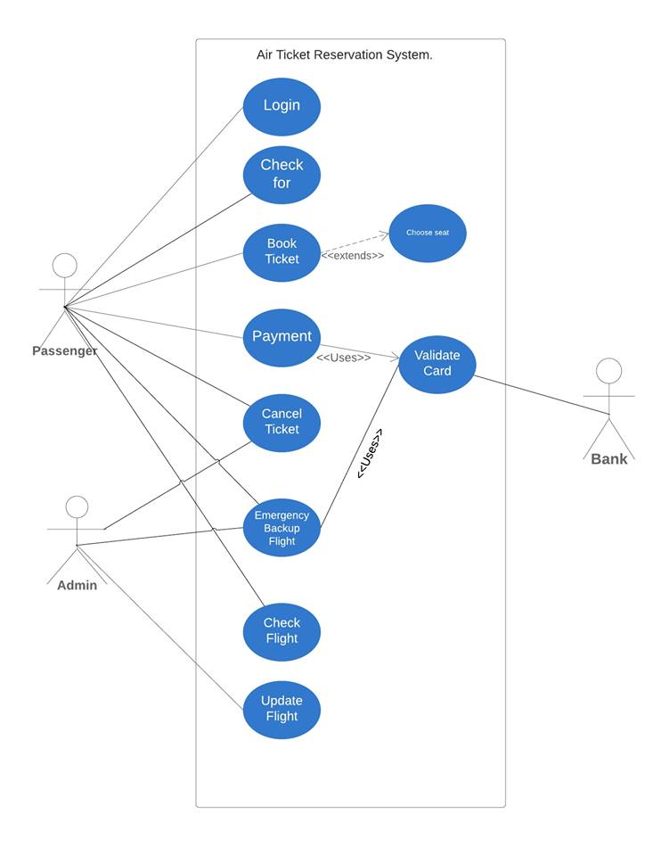

**Figure: Use Case Diagram**

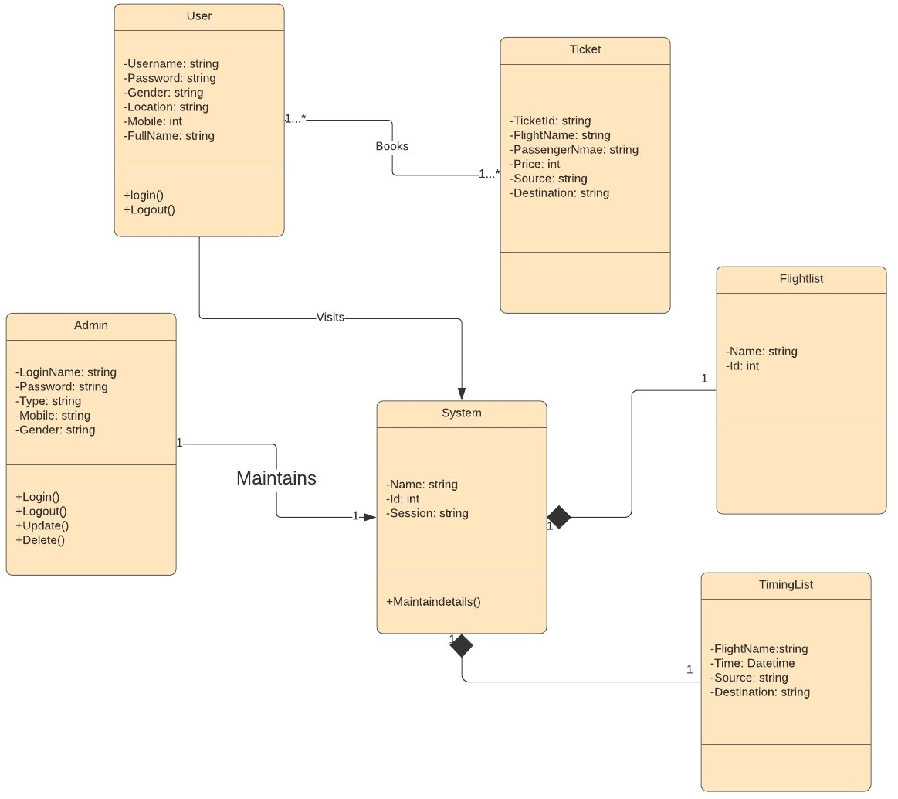

**Figure: Class Diagram**

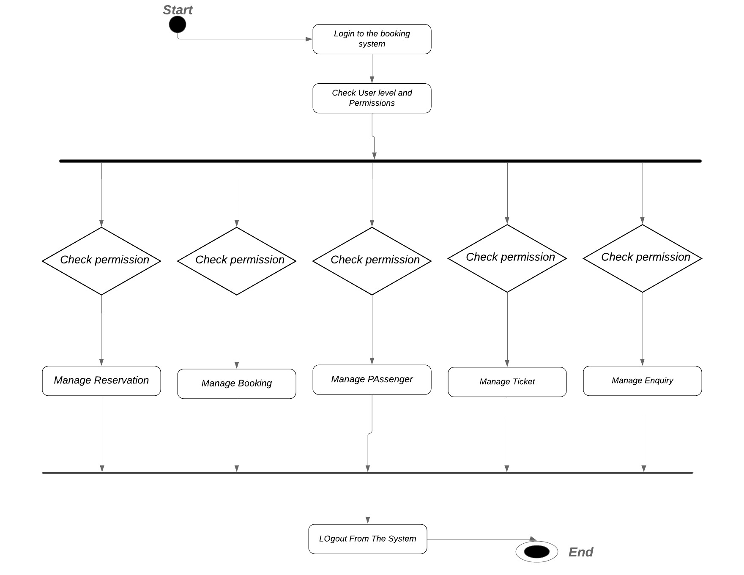

**Figure: Activity Diagram**

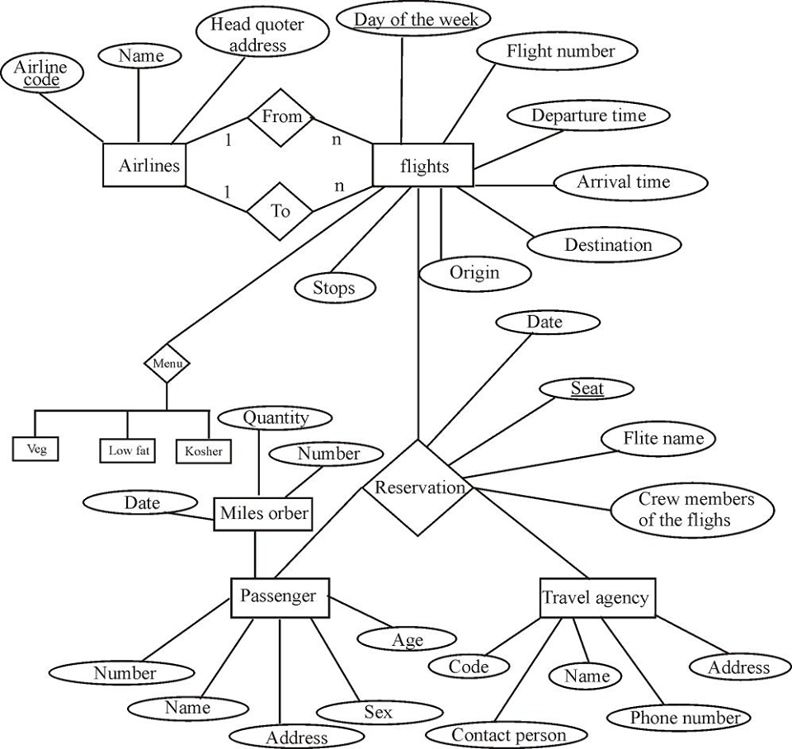

**Figure: E-R Diagram**

1. **Social Impacts:** The software system for this project will creates new opportunities has come a range of challenges that the air reservation companies must meet. These challenges are specific and varied for the companies, but have to be evaluated in the context of the global ecosystem that makes up the market and its links with other industries. The aim of the project will i) identify the potential current and future economic growth impact of the companies and their services specifically on social economy; ii) identify the elements that are determinant for its growth and competitiveness; iii) assess the future market impact and expected market transformation due to the emerging data-driven technologies; and iv) derive policy recommendations to remove barriers and foster the development of the industry.
2. **Development Plan**

**List of Task (Work Breakdown Structure)**

**Initiate Project**

1. **Develop Project Charted**
   * 1. Define Scope
     2. Define Requirements
     3. Identify High-Level Roles
     4. Develop High-Level Budget
     5. Identify High-Level Control Strategies
2. **Finalize Charter and Gain**
   * 1. Consolidate and publish project charter
     2. Hold review meeting
     3. Revise project charter
     4. Gain approvals from government
3. **Plan Project**
   * 1. Develop work plan
     2. Develop project staffing plan
     3. Develop project schedule
     4. Develop project budget
4. **Develop Project Control Plan**
   * 1. Develop communication plan
     2. Develop quality management plan
5. **Design**
   * 1. Define Stages and activities
     2. Design content Formats
     3. Object design Review
6. **Build**
   * 1. Write Code
     2. Project Review with Airline Agencies
7. **Testing**
   * 1. Unit Testing
     2. Test of Usability
8. **Implementation**
   * 1. Move tool to production environment
     2. Announce Tool Arability
9. **Close Project**

**Tasks Scheduling:**

|  |  |  |  |
| --- | --- | --- | --- |
| **Task** | **Start Date** | **Duration (Days)** | **End Date** |
| **Initiate Project** | **01/03/2020** | **30** | **02/04/2020** |
| **Develop Project charter** | 01/03/2020 | 15 | 16/03/2020 |
| Define Scope | 01/03/2020 | 5 | 06/03/2020 |
| Identify High Level Roles | 05/03/2020 | 2 | 07/03/2020 |
| Develop High level Budget | 08/03/2020 | 2 | 10/03/2020 |
| Identify High level Control Strategies | 20/03/2020 | 6 | 26/03/2020` |
| **Finalize Charter and Gain Approval** | **02/04/2020** | **10** | **12/04/2020** |
| Consolidate and publish project charter | 02/04/2020 | 3 | 05/04/2020 |
| Hold Review Meeting | 07/04/2020 | 2 | 09/04/2020 |
| Revise Project Charter | 08/04/2020 | 3 | 11/04/2020 |
| Gain Approvals from Government | 10/04/2020 | 2 | 12/04/2020 |
| **Plan Project (10%)** | **14/04/2020** | **28** | **12/05/2020** |
| **Develop Work Plan** | 14/04/2020 | 12 | 26/04/2020 |
| Develop Work breakdown structure | 20/04/2020 | 4 | 24/04/2020 |
| Develop Project Staffing Plan | 25/04/2020 | 4 | 29/04/2020 |
| Develop Project Schedule | 01/05/2020 | 4 | 05/05/2020 |
| Develop Project Budget | 06/06/2020 | 4 | 10/05/2020 |
| **Develop Project Control Plan** | **12/05/2020** | **10** | **22/05/2020** |
| Develop Communication plan | 12/05/2020 | 6 | 18/05/2020 |
| Develop Quality Management Plan | 18/05/2020 | 4 | 22/05/2020 |
| **Design** | **24/05/2020** | **10** | **04/06/2020** |
| Define stages and activities | 24/05/2020 | 4 | 28/05/2020 |
| Design content formats | 26/05/2020 | 3 | 29/05/2020 |
| Object design review | 01/06/2020 | 3 | 04/06/2020 |
| **Build** | **05/06/2020** | **45** | **20/07/2020** |
| Write Code | 05/06/2020 | 35 | 10/07/2020 |
| Project review with Client | 10/07/2020 | 10 | 20/07/2020 |
| **Testing** | **20/07/2020** | **30** | **20/08/2020** |
| Unit testing | 21/07/2020 | 20 | 11/08/2020 |
| Test of usability | 10/08/2020 | 10 | 20/08/2020 |
| **Implementation** | **21/08/2020** | **40** | **10/10/2020** |
| Move tool to production environment | 21/08/2020 | 20 | 10/09/2020 |
| Announce Tool Arability | 19/09/2020 | 20 | 10/10/2020 |
| **Close Project** | **11/10/2020** | **25** | **05/11/2020** |

**5. Marketing strategies & planning:**

**1**. **Telling a Story:** Modern marketing finds new ways of reaching customers by using real-life advertising scenarios. Storytelling has become a way to attract the attention of both current and potential passengers. Customers can relate to a company when they create an emotional attachment. For this reason, airlines create advertising that appeals to the emotional side of their consumer base.

**2.** **Social media world:** All a social influencer has to do is talk about a product on Twitter or Instagram and thousands of their followers immediately become potential customers. Smart airlines pay or allow social influencers to fly for free knowing it will attract an entirely new crop of future customers. Customers satisfaction and value for money. The value that you offer to your customer is directly proportional to the profit you make. So, an airline can start giving the real value to their customer via these social media sites. You may be thinking, what are these values in practical life? In practice, an airline, can create content on a topic like “what are the things that you should take care during your first flight?” An article written on this topic is helpful for all those who are travelling vial flight for the first time. So, if people read your content then, they are definitely going to book a ticket through you. So, sell less and give value more. An airline can also create videos and post them on YouTube to create brand awareness. By posting such videos and helpful guides about air travel, the brand value of any airline is going to skyrocket.

**3.** **Being Real Human:** Experts have found that consumers are impacted more by a human approach than they are with opulence. One easy way for airlines to do this is to use their actual staff in their commercials and branding. Customers can relate to real people at work – they can’t relate to celebrities.

**4.** **Enthusiastic Travelling offer:** A number of airlines have tapped into passengers’ craving for adventure. They increase overall sales by offering discounted flights and stopovers. When given the chance to experience a new city, many passengers can’t resist. Passengers now prefer airlines that offer the best vacation stop over destinations while traveling.

**5.** **Providing Flight Perks in the world of machines:** The airline industry faces a unique problem: customers want the convenience of a machine, but they crave the one-on-one interaction with an actual person. Airlines have invested in improving their machines and software to offer a more user-friendly process. They achieve flow and efficiency without treating customers like a herd of cattle. Creating an entertaining in-flight experience with features like in-seat systems that play current TV shows, music, games, or movies, can give you a customer advantage. For example, Open-Skies offered their passengers iPads with various entertainment options on select flights. By incorporating perks into your marketing strategy, you’ll entice more customers to choose your airline the next time they’re looking for a flight.

**6.Channel Uncertainty:** Unlike retail outfits, airlines have the unique problem of having to estimate their overhead. The costs of fuel, flight delays and other uncertainties make it harder for airlines to proactively set their bottom line. An effective marketing strategy for airlines must account for these uncertainties. Successful airlines build in a certain margin to compensate for thesedifficulties. As the needs and demands of the modern passenger changes, so must airline marketing strategies. Airlines need to step up their game if they want to dominate the airline industry.

**7. Providing Loyalty Programs:** By creating a loyalty program, you will encourage flyers to become repeat customers, booking additional flights with your business. Most airlines will charge the same fare for identical trips. By letting a customer become eligible for perks by earning points, you can gain an advantage over the competition. Perks can range from seat upgrades to free flights, airport lounge passes, or discounted parking spaces. Be creative and you’ll find that loyalty program members may book exclusively with you to maximize their benefits.

**8. A Creative Airline Advertising Strategy:** Thinking outside the box for advertising can help you work your way into your customers’ daily lives. The best airline advertising campaigns are a combination of traditional and non-traditional, so in addition to online and print marketing, make your presence known in the community. Air France sent trucks into New York City to distribute free food samples to people in various neighborhoods. Delta created Sky360 Lounges at sporting events and food festivals. Any way you can get your name out to the masses and get people to remember you is good for business.

**9.** **Impact Creating:** by helping society, which then becomes your loyal customer. American Airlines sends free food samples and packets to the people living near New York City. It is evident that people who have read about the work done by American Airlines in New York are going to respect their company, and building this respect is the most crucial part of any marketing campaign. This respect then turns into trust. It is a fact that customers who trust any company will always buy a ticket from it even though that company is charging them additional money. So, reach to the people through offline as well as online mode. Share them what you have done and let them know that you are a good company in the business.

**10.** **Offering backup flight:** If passengers have an emergency then agency can offer backup flight option and for that passengers don’t have to pay extra cost but if the backup flight is not used then the passengers can have their full refund. If by any chances flight is cancelled or delayed then the passengers will get rewords or will get back refund in case of flight cancellation.

**11.** **Air para-medical care:** air para-medics will get some extra features and cares.

1. **Cost and Profit Analysis**

|  |  |  |  |  |  |
| --- | --- | --- | --- | --- | --- |
| Cost Profit Analysis | 2020 | 2021 | 2022 | 2023 | Total |
| Development cost |  |  |  |  |  |
| Website design | 350000 |  |  |  | 350000 |
| Training |  | 5000 | 5000 | 5000 | 15000 |
| Software license | 20000 |  |  |  | 20000 |
| Data reservation cost | 7000 |  |  |  | 7000 |
| Total Development |  |  |  |  | 392000 |
|  |  |  |  |  |  |
| Save Cost |  |  |  |  |  |
| Decrease computers |  | 50000 | 65000 | 68500 | 183500 |
| Less amount of labor |  | 36000 | 38000 | 45000 | 119000 |
| Increased Conference Reservation |  | 110000 | 125000 | 132000 | 367000 |
| Increased Non-Conference Reservation |  | 120000 | 130000 | 135000 | 385000 |
| Total Save Cost |  |  |  |  | 1054500 |

Below provided cost profit analysis estimations shows that the system has a profitable return on the investment of nearly 69% over the next 3 years and from the first year the profit closes to the development cost. And the 2nd year the real profit can be counted.

Final Profit = (Total Save Cost – Total Development Cost) = (1054500 - 392000) = 662500